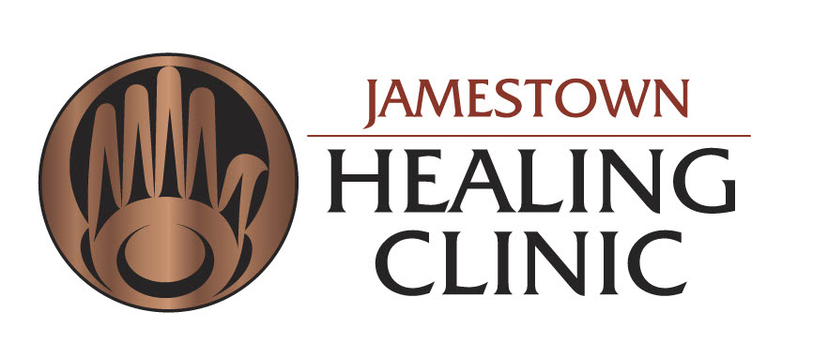

April 4, 2023

**A letter to Jamestown Healing Clinic patients,**

With the lifting of the state of Washington masking mandate, effective April 4, 2023, Jamestown Healing Clinic (JHC) will no longer require patients or clinic staff to wear a mask.

We will continue to offer surgical masks for all patients who choose to wear a mask during their visit. Everyone is asked to mask if experiencing symptoms of a contagious illness including: new fever, cough, or congestion and for those with known COVID-19 exposure in the past 10 days.

* **For those patients who have heightened concerns about your exposure to COVID-19 or other airborne illnesses, we recommend you wear a well-fitting mask of your choice during your time at JHC.**
* **Upon request, all clinical staff providing face to face care will wear a mask in your presence. Please let the front desk staff or your medical assistant know if this is your preference.**

We appreciate the patience and dedication to masking that all patients and staff have demonstrated these last few years. As we move together beyond the COVID-19 crisis era into our new shared normal, JHC remains committed to the safety and wellbeing of all patients and staff. We will continue to consult with our state and community healthcare leaders and public health officials to adjust our masking policy as local conditions change.

Thank you for choosing JHC for your healthcare needs.

**Molly Martin, DNP, ARNP**

Executive Director

Jamestown Healing Clinic